

NAME: BISMA FATIMA
CLASS: CS A
ROLL NO: F24605036
COURSE: COMPUTER NETWORK
COURSE CODE: CS-271
LECTURER: SIR NAVEED YOUSAF

LAB 04

Performing Initial Router Configuration
Warm up Task
Answer each question in your own words (3 to 4 lines)
1. What is a Router 🛣️
A router is a device that connects different computer networks and directs data between them. It reads dsata packets and decides the best path to send them to their destination. Routers are essential for accessing the internet and managing traffic between devices.
2. Features of Routers ⚙️
Routers offer features like packet forwarding, IP address assignment, and network security through firewalls. They support both wired and wireless connections, manage bandwidth, and often include VPN support for secure remote access.
3. Types of Routers 🧭
Common types include:
- Wired Routers: Use Ethernet cables for connections.
- Wireless Routers: Provide Wi-Fi access.
- Core Routers: Handle high-speed data within large networks.
- Edge Routers: Connect internal networks to external ones.
- Virtual Routers: Software-based, used in cloud environments.
4. Popular Companies Which Manufacture Routers 🏢
Leading router manufacturers include:
- Cisco – known for enterprise-grade routers
- Netgear – popular for home and small office use
- TP-Link – affordable and widely available
- D-Link – offers a range of consumer and business routers
- Asus – favored by gamers for high-performance models
5. Routing Table 📋
A routing table is a set of rules stored in a router that helps decide where to send data packets. It lists known networks, their paths, and the next hop for each destination. Routers consult this table to forward packets efficiently.
6. Router Operates on Which OSI Layer 🧩
Routers operate mainly at Layer 3, the Network Layer of the OSI model. This layer handles logical addressing (IP addresses) and routing decisions to move data between different networks.
7. Default Gateway 🚪
A default gateway is the device (usually a router) that sends data from a local network to other networks when no specific route is known. It acts as the exit point for devices to access external networks like the internet.
Task 1
By using Drag and drop draw the topology diagram as shown below and attach a screenshot of each step.
1. Pc
2. Switch (2950-24)
3.Router (Generic-PT)
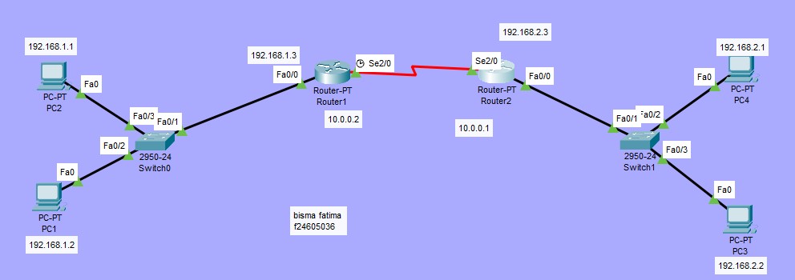
Figure 1. Packet Tracer Topology Diagram
Basic Router configuration
1. Continue with configuration dialog? [yes/no]: no
2. Press RETURN to get started! Press enter button
3. Router>en (enable)
4. Router#config t (configure terminal)
5. Router(config)#int fa0/0 (interface FastEthernet0/0)
6. Router(config-if)#ip address 192.168.1.3 255.255.255.0
7. no shut (no shutdown)
8. Router(config-if)#exit
9. Router(config)#
10. Router#config t
11. Router(config)#int se2/0 (Interface Serial2/0)
12. Router(config-if)#ip address 10.0.0.2 255.0.0.0
13. no shut (no shutdown)
14. exit
15. exit
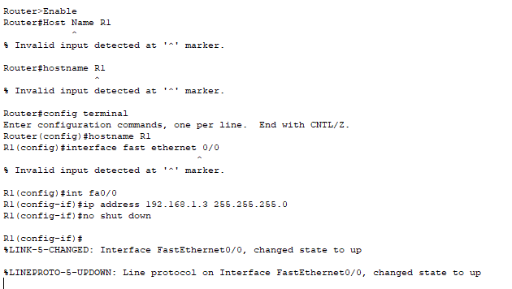
Figure Router 1 configration
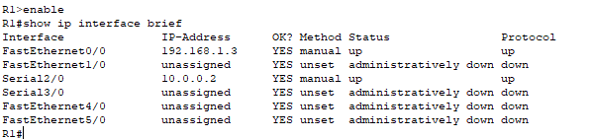
Figure : ip interface brief of router 1
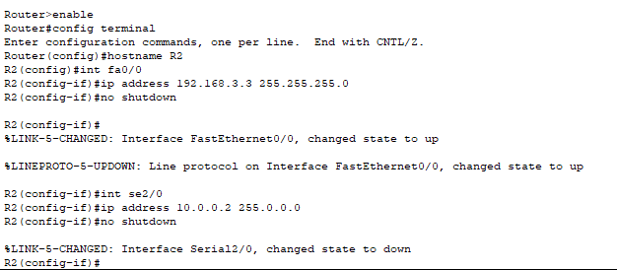
Figure router 2 configuration
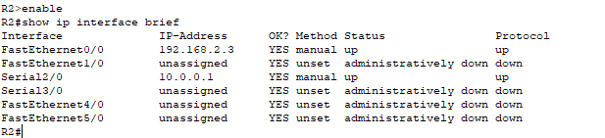
Figure : ip interface brief of router 2
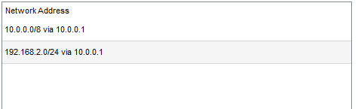
Figure . Static Routes table for R1
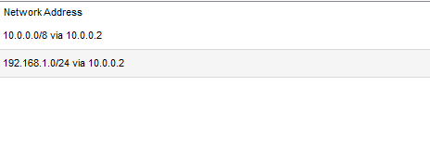
Figure . Static Routes table for R2
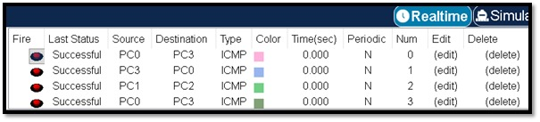
Figure : packet transfer

Task 2: Draw given topology diagrams and attach screen shots of Pcs communication
∙ Label each device with a unique ip address.
∙ Highlight different sections
∙ Divide given topology in three different networks
∙ Ping one laptop to other network laptops.
∙ Send packets (Real time).
∙ Send packets(Simulation).
∙ Take screen shots of routing table of each router
∙ Take screen shots of routers configurations
∙ Assign routes through router configuration
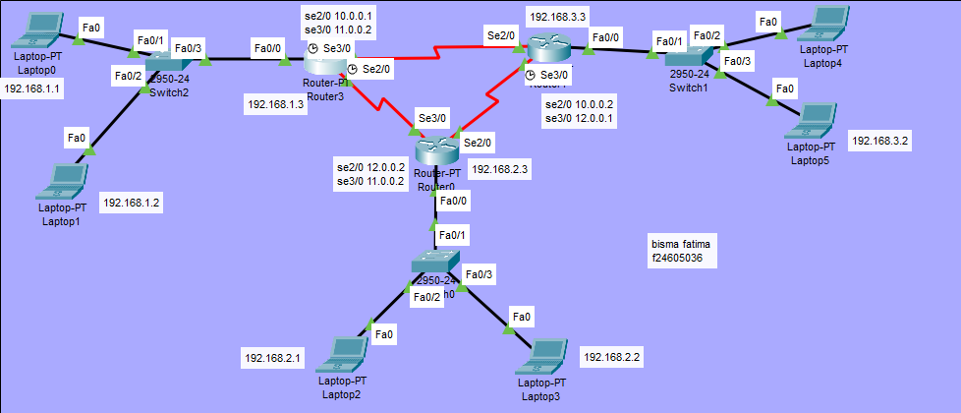 Figure 3. Task 2 topology diagram
ROUTER CONFIGURATION OF R1
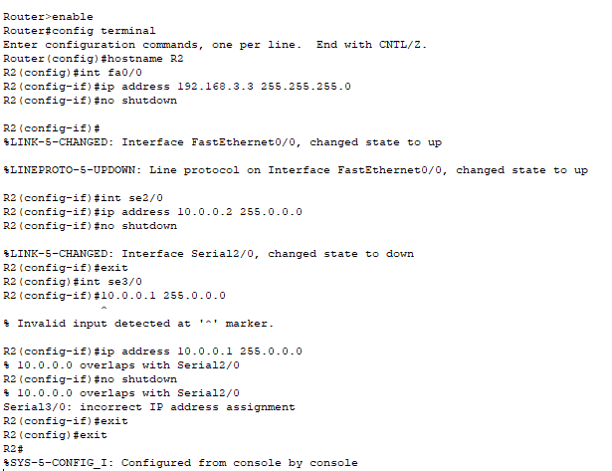
ROUTER CONFIGURATION OF R2

Static routes R1:
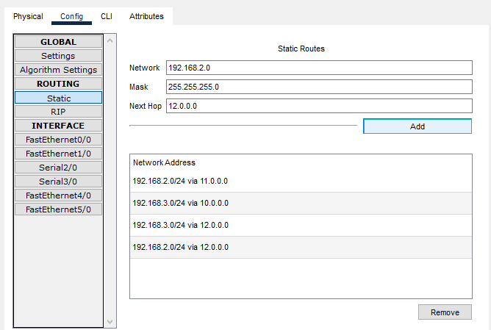
Static routes R2:
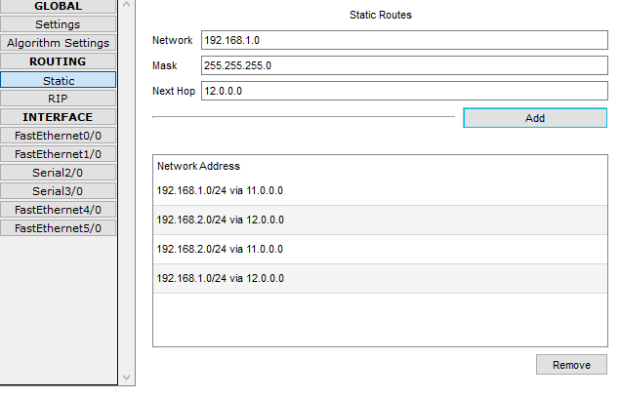
Static routes R3:
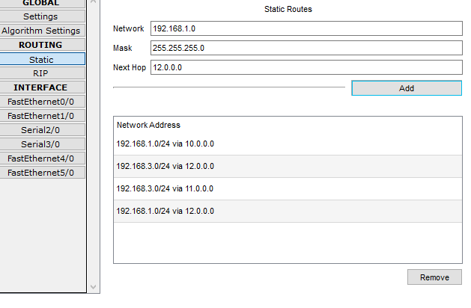
PING LAPTOP 1 TO LAPTOP 5
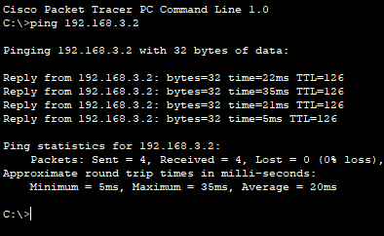
. Send packets (Real time).
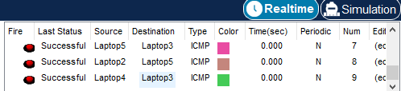
∙ Send packets(Simulation).
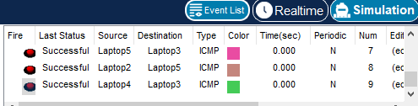
Routers configurations of R1
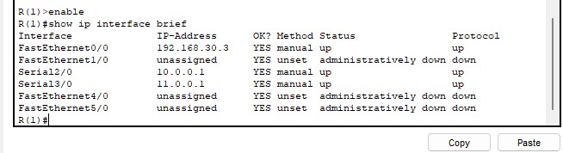
Routers configurations of R2
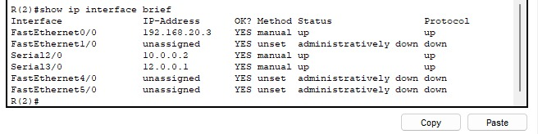
Routers configurations of R3
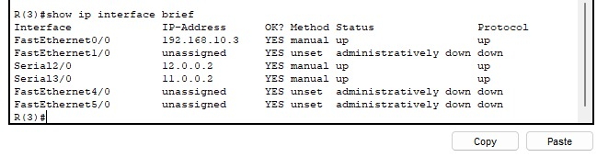
Router routes R1
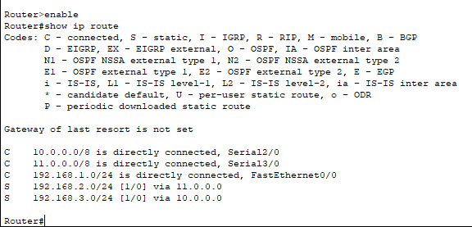
Router routes R2
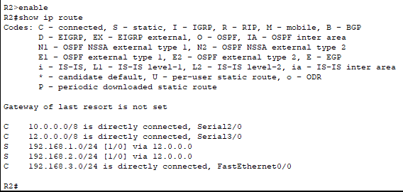
Router routes R3
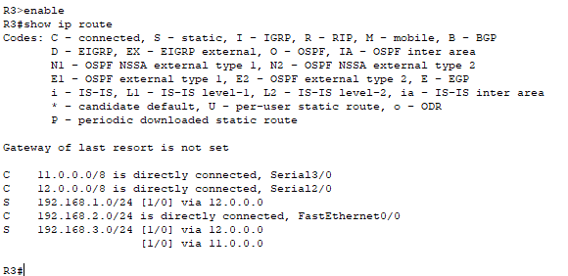
Task 3:
Difference between static routing and dynamic routing
Feature | Static Routing 🛣️ | Dynamic Routing 🔄
Definition | Routes are manually configured by the admin | Routes are automatically learned and updated
Adaptability | Non-adaptive; doesn't change unless manually updated | Adaptive; adjusts to network changes automatically
Complexity | Simple to configure in small networks | More complex; requires routing protocols
Routing Protocols Used | None | Uses protocols like RIP, OSPF, EIGRP
Resource Usage | Low CPU and memory usage | Higher CPU and memory usage due to calculations
Security | More secure (less exposure to external changes) | Less secure (more open to route manipulation)
Scalability | Poor scalability for large networks | Highly scalable and efficient for large networks
Failure Recovery | Manual intervention needed | Automatic rerouting in case of failure

